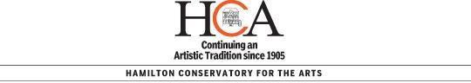

REGISTRATION/RECEIPT FORM 2019/2020
Date of Registration: | New or Returning to class: Please check one  NEW RETURNING |  |  |  | Date of Birth:
 |  |  |  |  | Entering Grade:
Student Name:
Parent /Guardian
Address:
Email Address:
Main Telephone: |  | Alternate Telephone:
CLASS NAME | TEACHER |  | DAY OF CLASS | TIME |  | AMOUNT
PAYMENT BY: CASH DEBIT CHEQUE VISA M/C |  |  |  | REGISTRATION FEE
 |  |  |  | MATERIAL FEE
 |  |  |  | COSTUME FEE
 |  |  |  | TOTAL
Post-dated cheques rcvd: S O N D J F M A M J Pre auth credit card rcvd: |  |  |  | TOTAL SAVINGS
Please specify if name on cheque is different than student's last name:
Please list any medical conditions/Allergies/Behavioural Concerns:
If you are a music student, will you be taking the RCM exam this year? YES NO Will you be participating in performance classes? YES NO
There are times when the media runs stories of the activities we have at HCA, or we like to take photographs and/or video tapings to be kept on file, and used in future promotional and/or informational brochures, posters, newsletters, web pages and advertisements for HCA and other related publications.
Do you give consent to your child to be photographed or video taped? YES NO

I have read the Code of Conduct and Payment Information printed on the reverse of this Registration Form and agree to and accept the terms outlined.

Signature of Adult Student/Parent/Guardian Date
Signature of Administrator/Administrator Assistant Date
Telephone: (905) 528-4020 Fax: (905) 525-3007 E-mail: info@hcarts.ca Website: www.HCArts.ca HAMILTON CONSERVATORY FOR THE ARTS - 126 JAMES STREET SOUTH, HAMILTON , ON L8P 2Z4

